Submitted By
Student Name | Astitva Sharma
Roll No | 24/SCA/BCA(Al&ML)/011
Program | BCA(AI&ML)
Subject | Python Programming
Semester | 3
Section/Group | C
Department | School of Computer Applications
Session / Batch | 2024-27
Submitted To
Faculty Name | Dr.Sakshi Gupta
Manav Rachna International Institute of Research and Studies

School of Computer Applications

Q1) Write a Python program to calculate number of days between two dates.

from datetime import date

y1, m1, d1 = map(int, input("Enter first date (YYYY MM DD): ").split())
y2, m2, d2 = map(int, input("Enter second date (YYYY MM DD): ").split())

date1 = date(y1, m1, d1)
date2 = date(y2, m2, d2)

delta = abs(date2 - date1)
print(f"Number of days between: {delta.days} days")
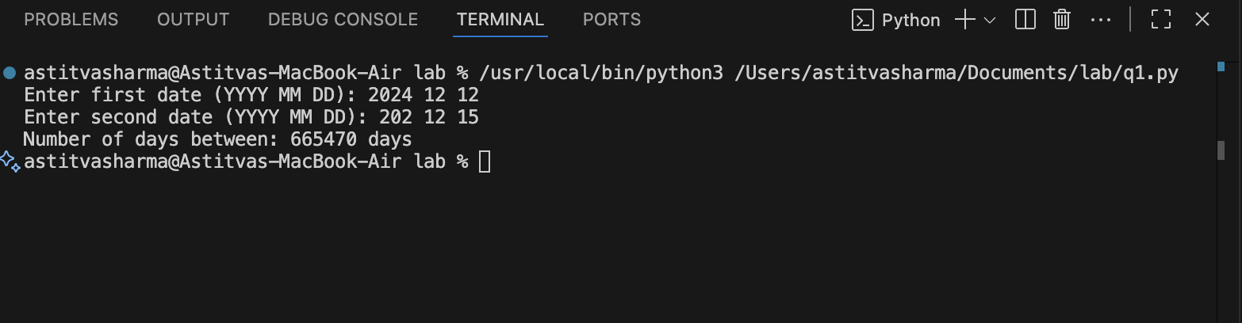

Q2) Write a Python program that accepts an integer (n) and computes the value of n+nn+nnn.

n = int(input("Enter a number: "))

result = n + int(str(n)*2) + int(str(n)*3)
print("Result:", result)
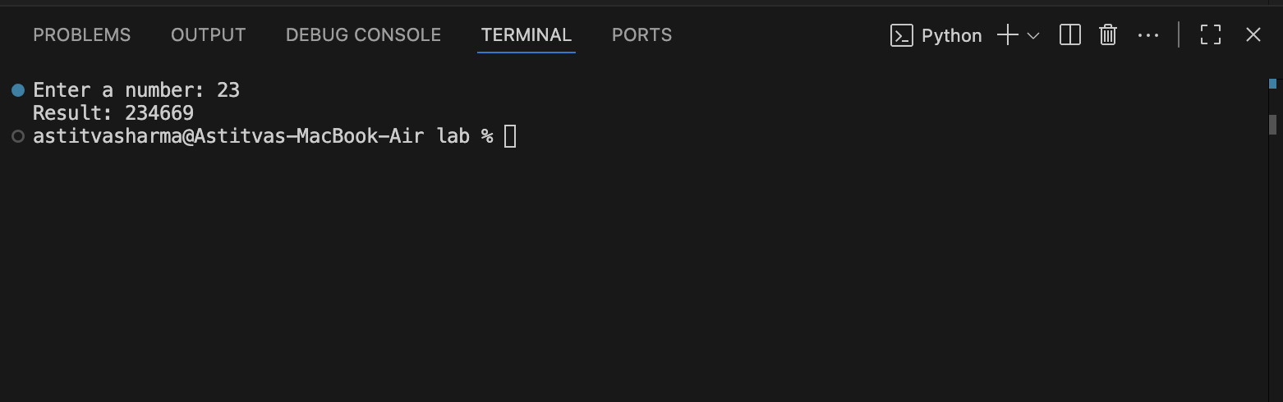

Q3) Ask the user for a number. Depending on whether the number is even or odd, print out an appropriate message to the user. Hint: how does an even / odd number react differently when divided by 2?

num = int(input("Enter a number: "))

if num % 2 == 0:
print(f"The number {num} is EVEN. That means it is divisible by 2 without any remainder.")
else:
print(f"The number {num} is ODD. That means when divided by 2, it leaves a remainder of 1.")

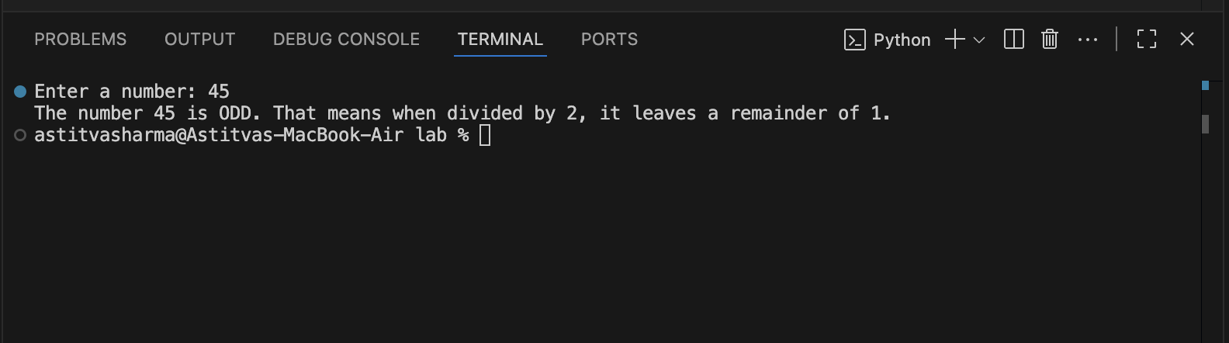

Q4) Write a Python program which accepts a sequence of comma-separated numbers from user and generate a list
and a tuple with those numbers.

numbers = input("Enter numbers separated by commas: ")
num_list = numbers.split(",")
num_tuple = tuple(num_list)
print("List:", num_list)
print("Tuple:", num_tuple)
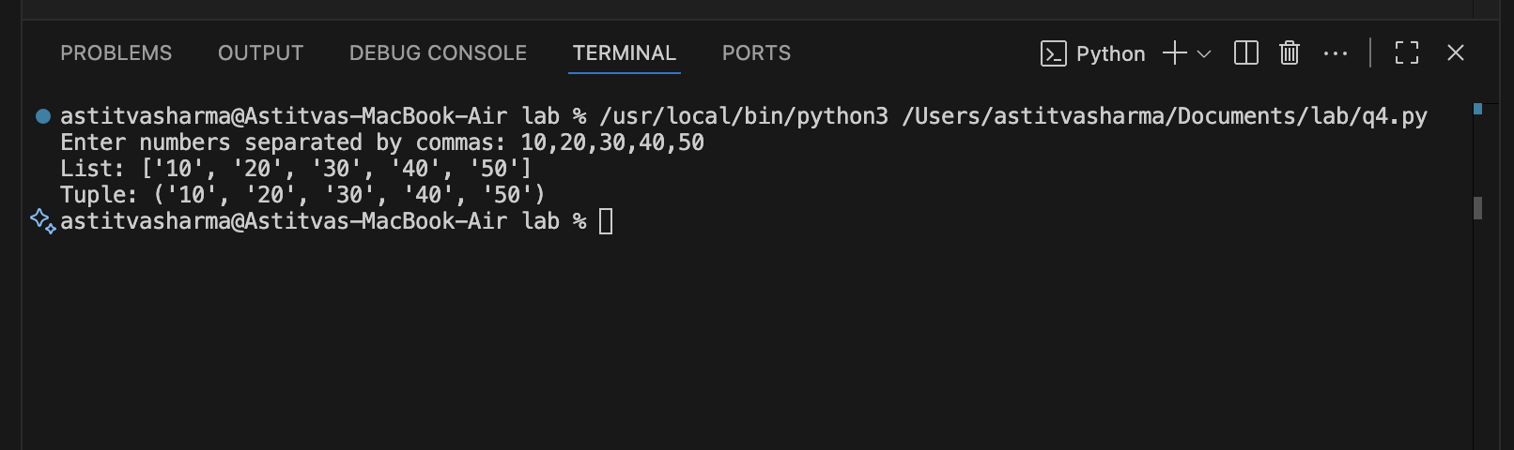

Q5) Write a Python program to calculate the sum of three given numbers, if the values are equal then return thrice of their sum.

a = int(input("Enter first number: "))
b = int(input("Enter second number: "))
c = int(input("Enter third number: "))

if a == b == c:
print("Result:", 3 * (a + b + c))
else:
print("Result:", a + b + c)

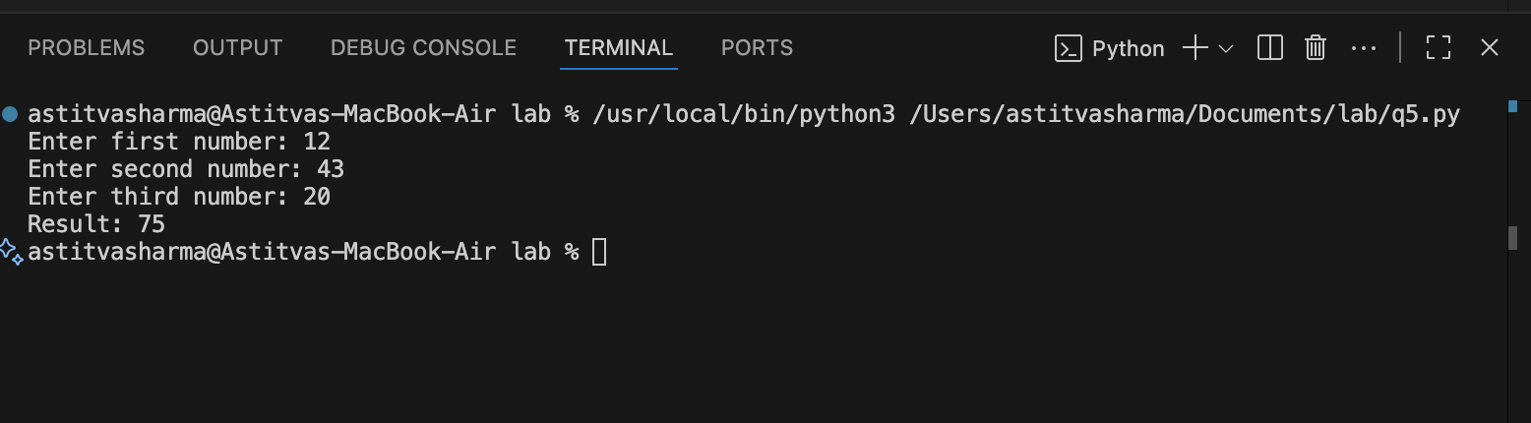

Q6) Write a Python program to test whether a passed letter is a vowel or not.

ch = input("Enter a letter: ")

if ch.lower() in "aeiou":
print(ch, "is a vowel")
else:
print(ch, "is not a vowel")
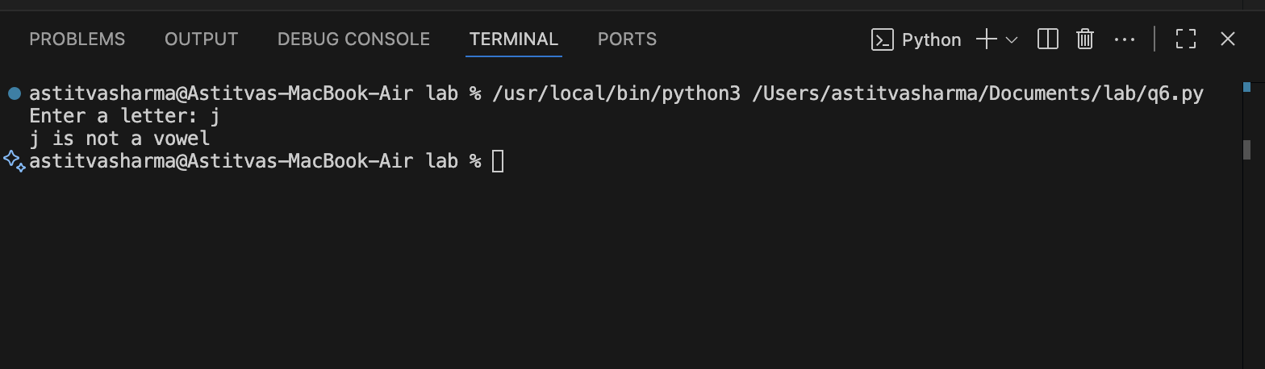

Q7)Take a list, say for example this one:
a = [1, 1, 2, 3, 5, 8, 13, 21, 34, 55, 89]
and write a program that prints out all the elements of the list that are less than 5.
Extras:

- Instead of printing the elements one by one, make a new list that has all the elements less than 5 from this list in it and print out this new list.
- Write this in one line of Python.
Ask the user for a number and return a list that contains only elements from the original list a that are smaller than that number given by the user.

a = [1, 1, 2, 3, 5, 8, 13, 21, 34, 55, 89]
for i in a:
if i < 5:
print(i)
new_list = [x for x in a if x < 5]
print("New List:", new_list)
print([x for x in a if x < 5])
num = int(input("Enter a number: "))
print([x for x in a if x < num])
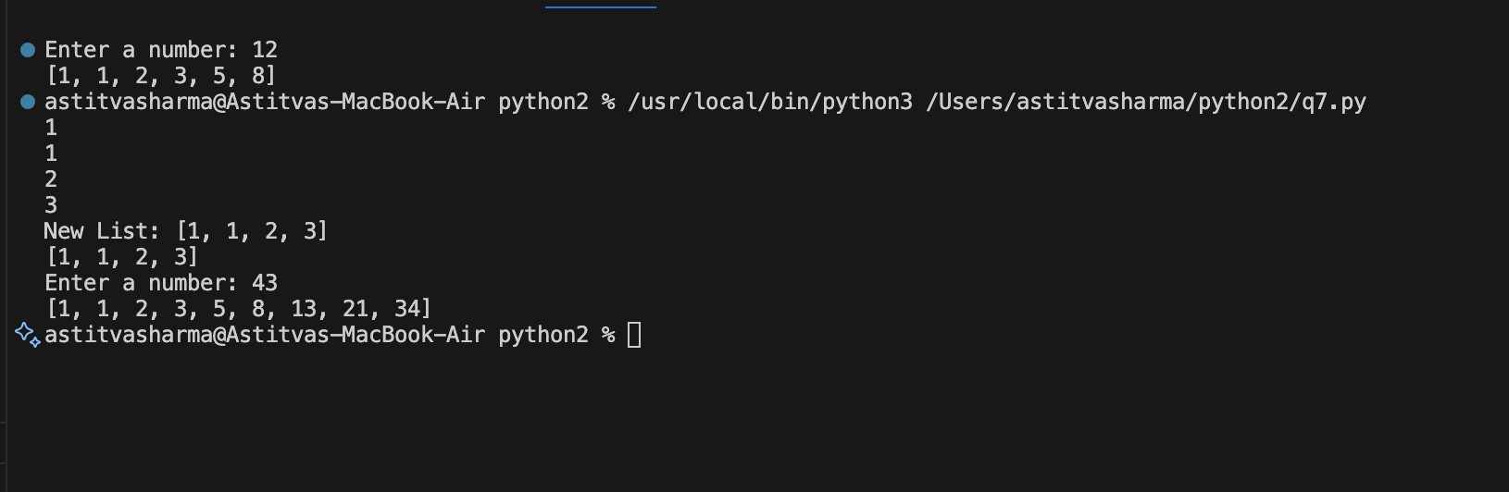

Q8)Create a program that asks the user for a number and then prints out a list of all the divisors of that number. (If you don’t know what a divisor is, it is a number that divides
evenly into another number. For example, 13 is a divisor of 26 because 26 / 13 has no remainder.)

n = int(input("Enter a number: "))
divisors = [i for i in range(1, n + 1) if n % i == 0]
print("Divisors of", n, "are:", divisors)

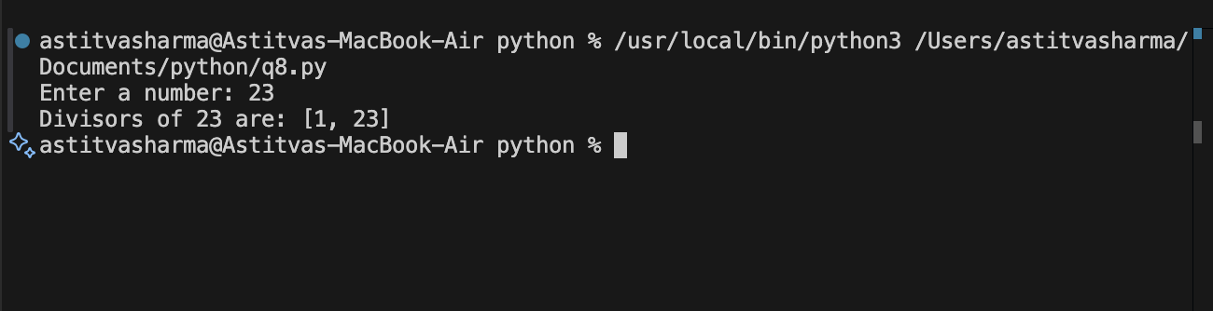

Q9)Take two lists, say for example these two:
a = [1, 1, 2, 3, 5, 8, 13, 21, 34, 55, 89]
b = [1, 2, 3, 4, 5, 6, 7, 8, 9, 10, 11, 12, 13]
and write a program that returns a list that contains only the elements that are common between the lists (without duplicates). Make sure your program works on two lists of
different sizes.

a = [1, 1, 2, 3, 5, 8, 13, 21, 34, 55, 89]
b = [1, 2, 3, 4, 5, 6, 7, 8, 9, 10, 11, 12, 13]
common = list(set(a) & set(b))
print("Common elements:", common)

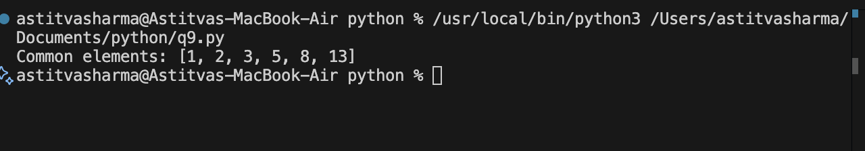

Q10) Ask the user for a string and print out whether this string is a palindrome or not. (A palindrome is a string that reads the same forwards and backwards.)

s = input("Enter a string: ")
if s == s[::-1]:
print("Palindrome")
else:
print("Not a palindrome")

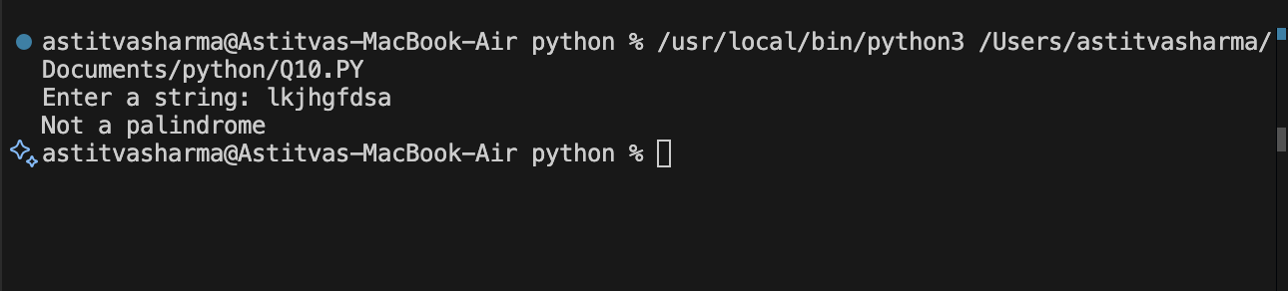

Q11)Let’s say I give you a list saved in a variable: a = [1, 4, 9, 16, 25, 36, 49, 64, 81, 100]. Write one line of Python that takes this list a and makes a new list that has only the even elements of this list in it.

a = [1, 4, 9, 16, 25, 36, 49, 64, 81, 100]
even_list = [x for x in a if x % 2 == 0]
print("Even elements list:", even_list)

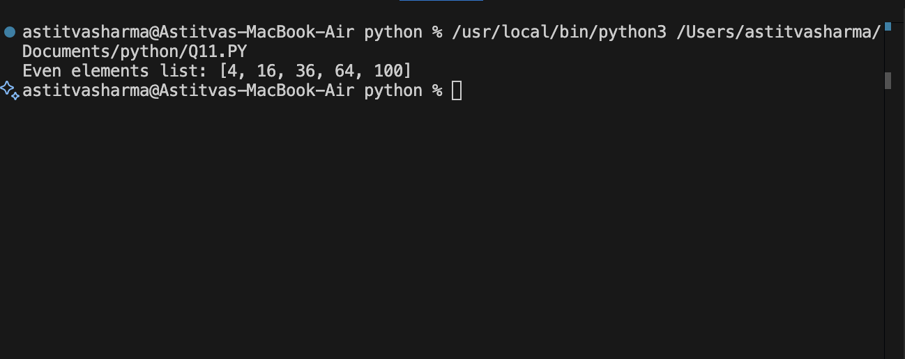

Q12)Generate a random number between 1 and 9 (including 1 and 9). Ask the user to guess the number, then tell them whether they guessed too low, too high, or exactly right. (Hint: remember to use the user input lessons from the
very first exercise)

import random

num = random.randint(1, 9)
guess = int(input("Guess a number between 1 and 9: "))

if guess < num:
print("Too low!")
elif guess > num:
print("Too high!")
else:
print("Exactly right!")

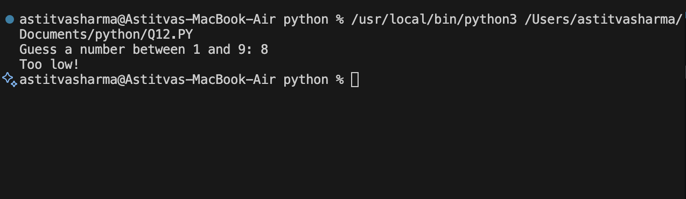
Ask the user for a number and determine whether the
13.Ask the user for a number and determine whether the
number is prime or not.

num = int(input("Enter a number: "))

# Prime numbers are greater than 1
if num > 1:
for i in range(2, num):
# if number is divisible by any number other than 1 and itself
if num % i == 0:
print(num, "is not a prime number.")
break
else:
print(num, "is a prime number.")
else:
print(num, "is not a prime number.")

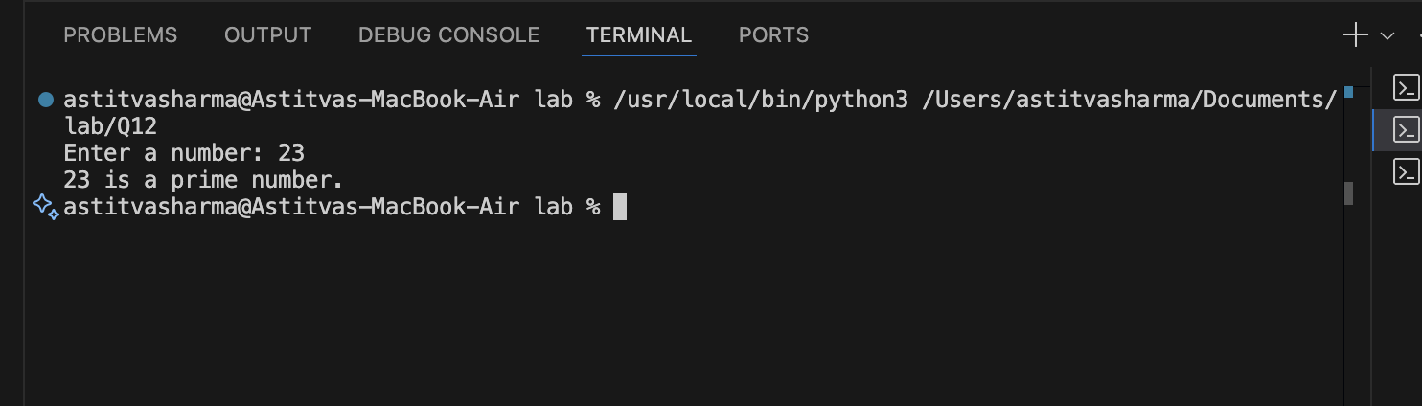

Q14- Write a program (function!) that takes a list and returns a
new list that contains all the elements of the first list minus all the duplicates.
def remove_duplicates(my_list):
new_list = []
for item in my_list:
if item not in new_list:
new_list.append(item)
return new_list

user_input = input("Enter numbers separated by spaces: ")
user_list = user_input.split()

result = remove_duplicates(user_list)

print("List without duplicates:", result)
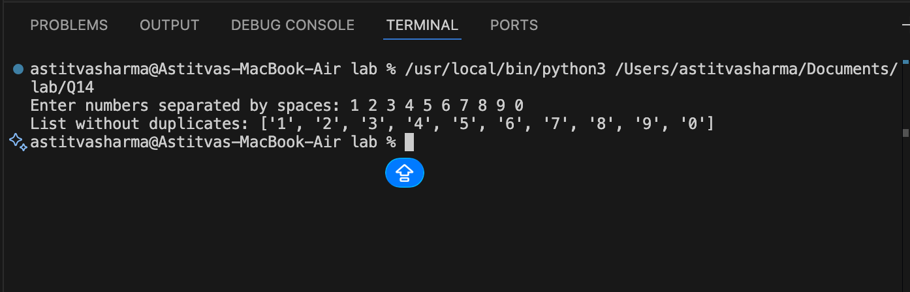

Q15- Write a function that takes an ordered list of numbers (a list where the elements are in order from smallest to largest) and another number. The function decides whether
or not the given number is inside the list and returns (then prints) an appropriate boolean.
def find_number(ordered_list, number):
for item in ordered_list:
if item == number:
return True
elif item > number:
return False
return False

user_list = list(map(int, input("Enter sorted numbers separated by spaces: ").split()))
num = int(input("Enter number to search: "))

print(find_number(user_list, num))
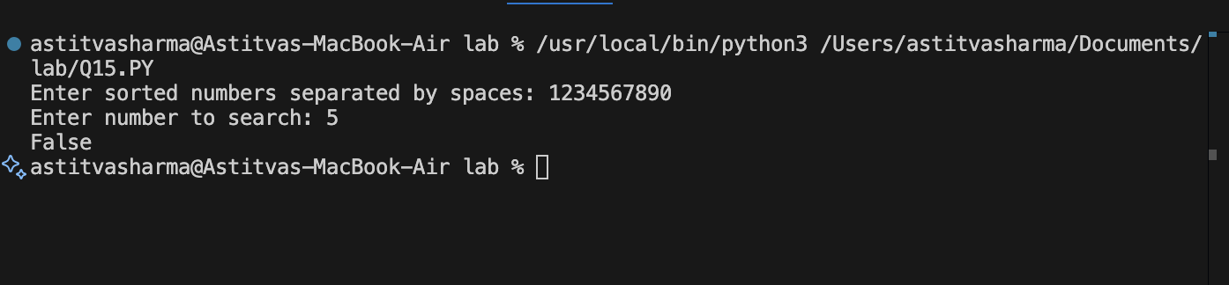

16. Implement a function that takes three variables and returns the largest without using max().
def largest(a, b, c):
if a >= b and a >= c:
return a
elif b >= a and b >= c:
return b
else:
return c

x = float(input("Enter first number: "))
y = float(input("Enter second number: "))
z = float(input("Enter third number: "))

print("Largest number is:", largest(x, y, z))
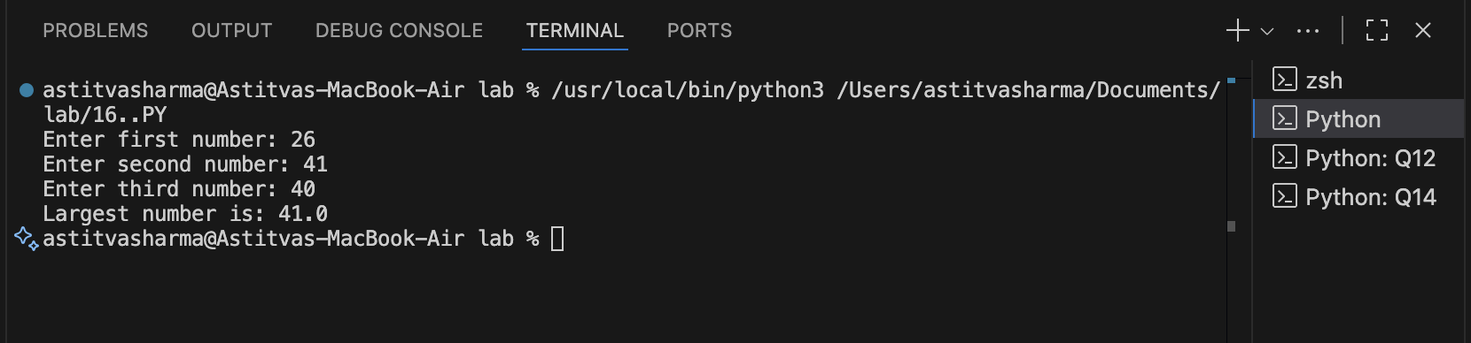

17. Python program to perform read and write operations on a file.
# Writing to a file
file = open("example.txt", "w")
file.write("Hello, this is a sample text file.\n")
file.write("Python file handling example.")
file.close()

# Reading from the file
file = open("example.txt", "r")
content = file.read()
file.close()

print("File content:")
print(content)
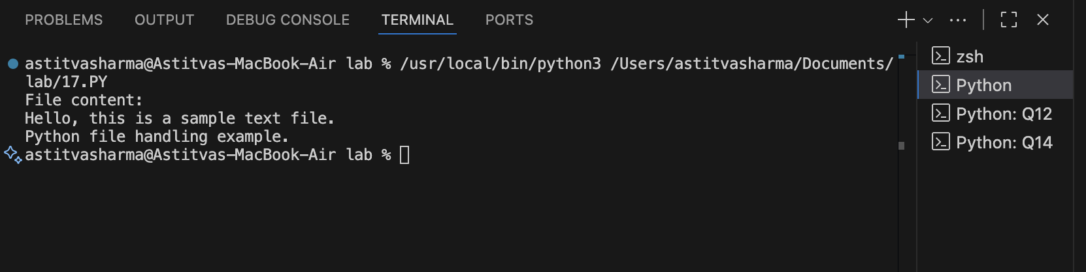

18. Python program to copy the contents of a file to another file.
source = input("Enter source file name: ")
destination = input("Enter destination file name: ")

file1 = open(source, "r")
data = file1.read()
file1.close()

file2 = open(destination, "w")
file2.write(data)
file2.close()

print("File copied successfully.")

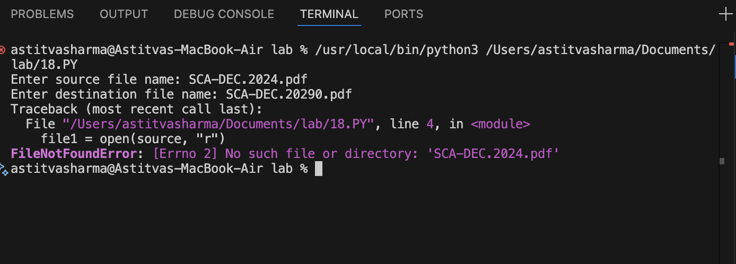

19. Python program to count frequency of characters in a given file.

filename = input("Enter file name: ")

file = open(filename, "r")
text = file.read()
file.close()

freq = {}

for char in text:
if char in freq:
freq[char] += 1
else:
freq[char] = 1

print("Character Frequency:")
for char, count in freq.items():
print(f"'{char}' : {count}")

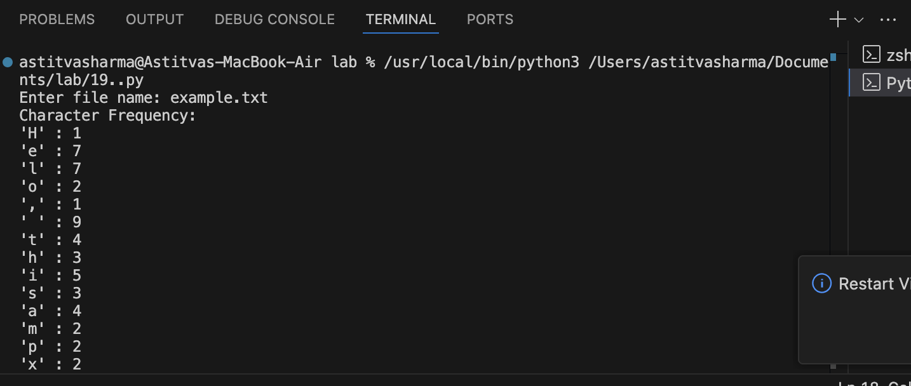
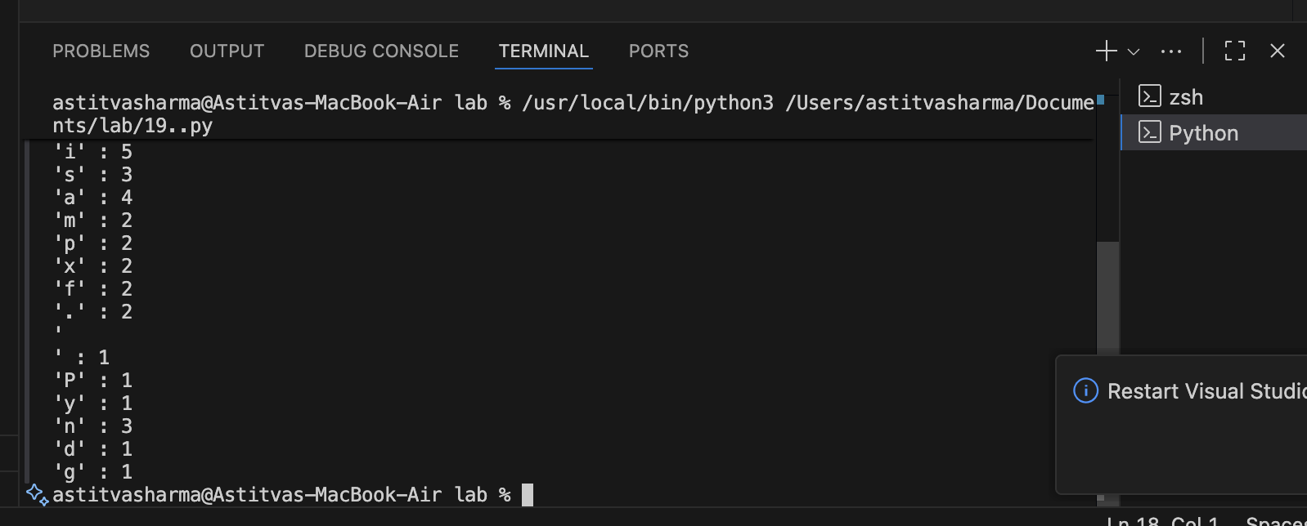

20. Python program to print each line of a file in reverse order.

filename = input("Enter file name: ")

file = open(filename, "r")
lines = file.readlines()
file.close()

for line in lines:
print(line[::-1])

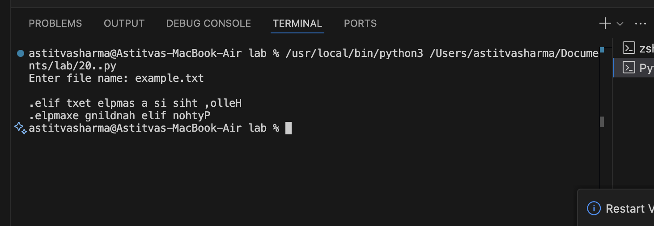

21. Python program to compute the number of characters, words and lines in a file.
filename = input("Enter file name: ")

file = open(filename, "r")
text = file.read()
file.close()

lines = text.split("\n")
words = text.split()
characters = len(text)

print("Number of lines:", len(lines))
print("Number of words:", len(words))
print("Number of characters:", characters)

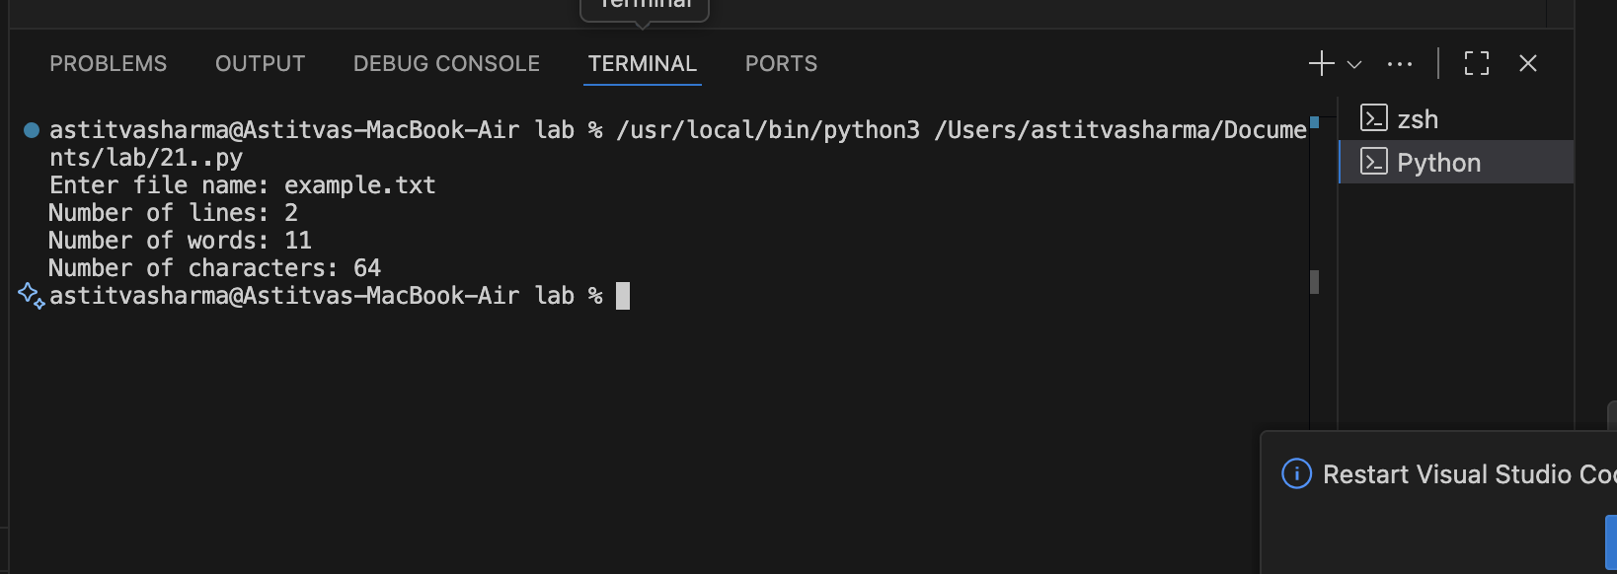
22. Program that greets the user unless their name is Rahul, then throws an exception.
name = input("Enter your name: ")

if name == "Rahul":
raise Exception("Access denied for Rahul!")
else:
print("Hello", name + "!")
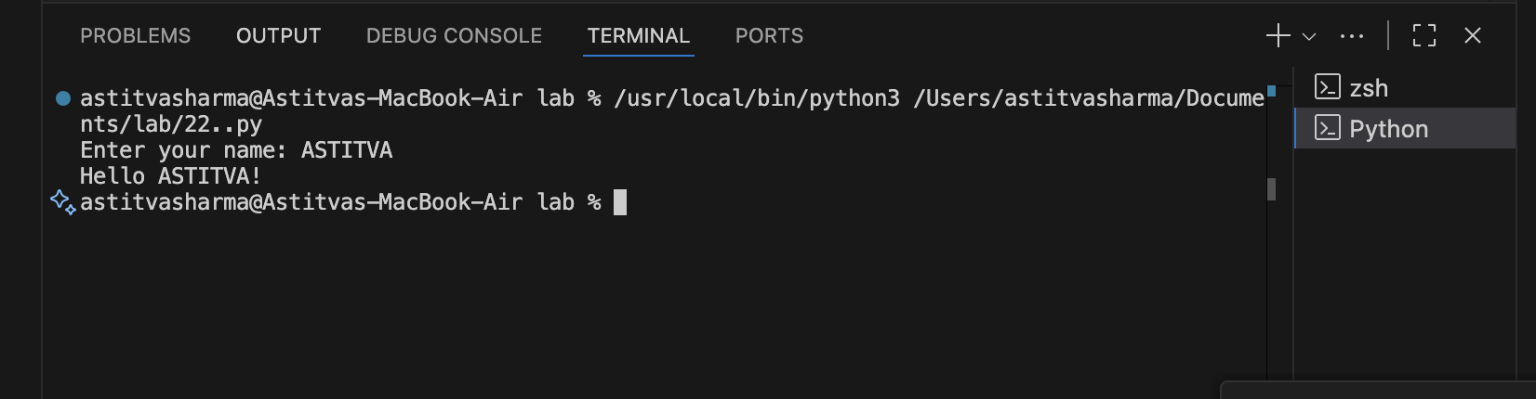

23. Program that accepts personal details and DOB, raising exception for invalid date.
from datetime import datetime

# User-defined exception for invalid date
class InvalidDateError(Exception):
"""Custom exception raised when an invalid date of birth is entered."""
pass

def validate_dob(dob_str):
"""
Validates the date of birth string.
Expected format: DD-MM-YYYY
Raises InvalidDateError if the date is invalid.
"""
try:
# Try converting string to a date
dob = datetime.strptime(dob_str, "%d-%m-%Y")
return dob
except ValueError:
# datetime raises ValueError if the date or format is wrong
raise InvalidDateError("Invalid Date of Birth! Please enter a valid date in DD-MM-YYYY format.")

def main():
try:
print("=== Enter Personal Details ===")
name = input("Enter your name: ")
email = input("Enter your email: ")
phone = input("Enter your phone number: ")
dob_input = input("Enter your Date of Birth (DD-MM-YYYY): ")

# Validate the DOB
dob = validate_dob(dob_input)

except InvalidDateError as e:
print("Error:", e)
else:
# This block runs only if no exception occurred
print("\n=== Details Saved Successfully ===")
print("Name :", name)
print("Email :", email)
print("Phone :", phone)
print("DOB :", dob.strftime("%d-%m-%Y"))
finally:
print("\nProgram ended.")

# Call main
if __name__ == "__main__":
main()

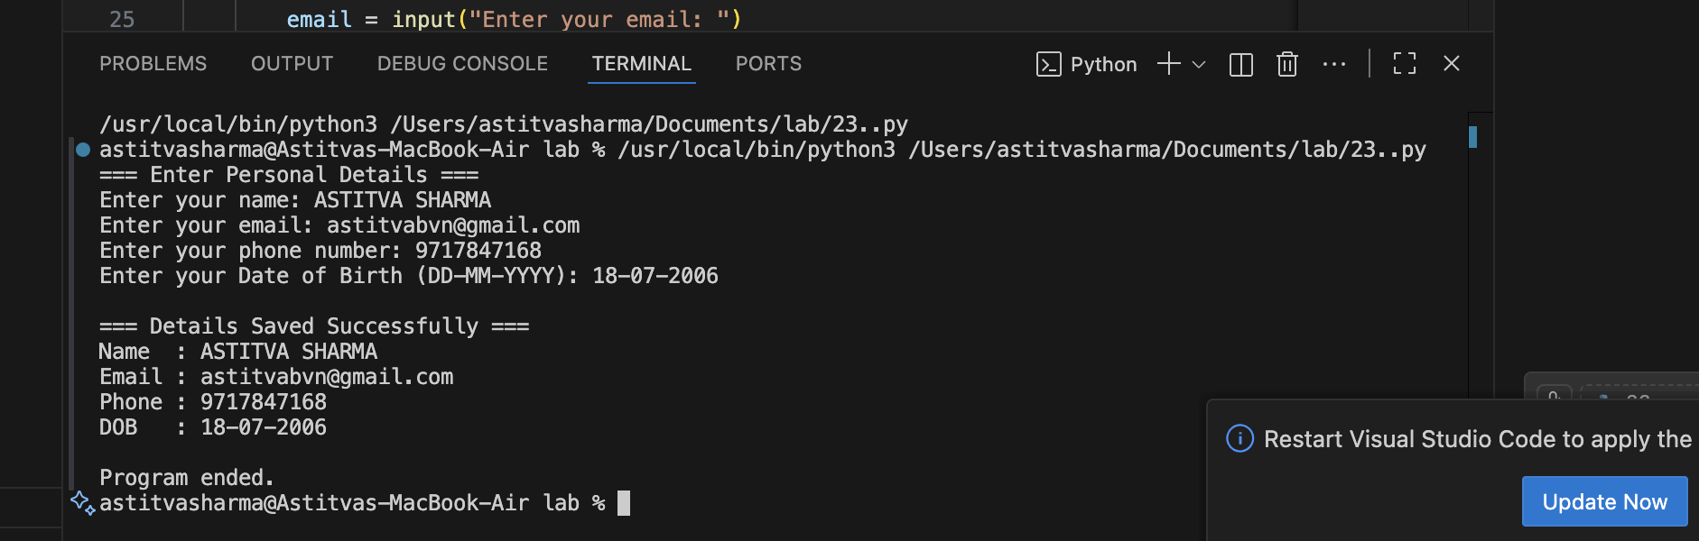

24. Regular Expression to check valid 10-digit mobile number starting with 7,8 or 9.
import re

pattern = r"^[789][0-9]{9}$"

mobile = input("Enter a 10-digit mobile number: ")

if re.match(pattern, mobile):
print("Valid Mobile Number 👍")
else:
print("Invalid Mobile Number ❌")

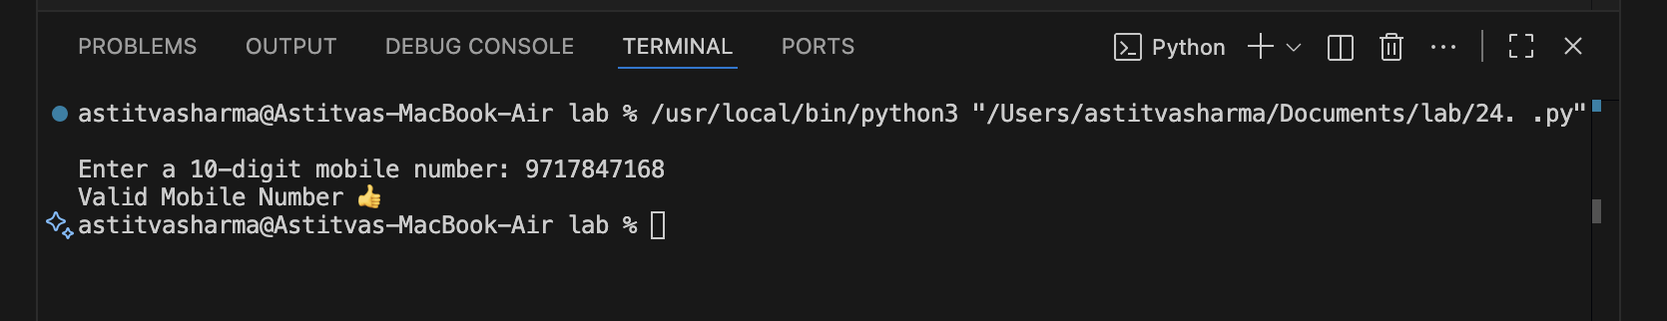

25. Program that checks spelling mistakes using a dictionary file.
def load_dictionary(filename):
"""Loads dictionary words from a text file into a set."""
try:
with open(filename, "r") as file:
words = {word.strip().lower() for word in file}
return words
except FileNotFoundError:
print("Dictionary file not found!")
return set()

def check_spelling(sentence, dictionary_words):
"""Checks spelling mistakes in a given sentence."""
sentence_words = sentence.lower().split()
incorrect_words = []

for word in sentence_words:
# Remove punctuation if needed
cleaned_word = ''.join(char for char in word if char.isalpha())

if cleaned_word and cleaned_word not in dictionary_words:
incorrect_words.append(cleaned_word)

return incorrect_words

# -------- Main Program -------- #
dictionary = load_dictionary("dictionary.txt")

if dictionary:
user_input = input("Enter a sentence: ")
mistakes = check_spelling(user_input, dictionary)

if mistakes:
print("\nMisspelled Words Found:")
for w in mistakes:
print("-", w)
else:
print("\nNo spelling mistakes detected ✔️")

print("\nProgram Finished.")

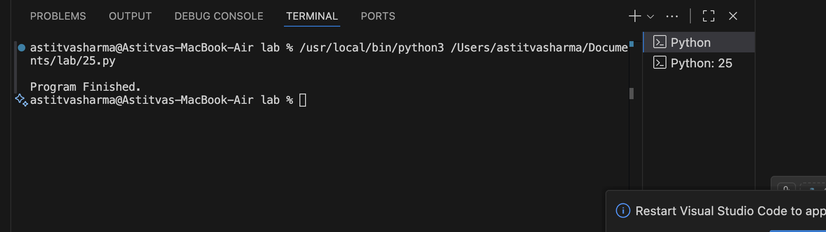s

